Grammars and Semantics

What is a Language?
The text (page 160) defines a language as "… a set of strings of symbols from a finite alphabet." For example, the set of upper and lower case letters, numbers, and punctuation (including diacritical marks) constitutes the alphabet which is formed into units. Some units are called words, others are called sentences, others paragraphs, etc. The usual basic unit of a language is considered to be a sentence.
What is missing here are the rules of how such units are formed. Not every set of strings from an alphabet would be considered valid in a particular language. Thus languages also have rules about how sentences are formed.

What Are Grammars and Semantics?
The rules can be divided into two main categories. Syntax is how sentences in a language are technically constructed. That is, how sentences are written. A grammar contains the syntax rules. However, perfectly constructed sentences may not mean anything or have unintended meanings. Semantics looks at the meaning of sentences.
To give a programming language example, we know that it can be challenging to get a program to compile. A compiler is a syntax checker that uses a grammar to validate the correct construction of program statements (sentences). Getting a program to compile does not mean, as we also know, that a program will work. The semantics of the program may be faulty leading to crashes and/or incorrect results. We also know that it is usually harder to validate the semantics than to validate the syntax.
To go to a more detailed level, we may write a legal C++ loop but there is no guarantee that it will terminate or iterate for as many times as we expect. We have a tool, a compiler, to validate loop syntax, but we have to test in order to validate the loop semantics.

Why Study Grammar and Semantics?
One reason is that compilers and interpreters require some type of grammar in order to validate whether a given string is part of a programming language. The part of a translator that does this syntax analysis is called a recognizer. Another part of the compiler uses a grammar in order to write language sentences in assembly language, then machine language. This type of program is called a generator.
Another reason is less applied and more theoretical. The Software Crisis of the 1960s spurred researchers to find ways of making programming languages less susceptible to errors. One way that had been considered for many years, even prior to the Crisis, was to put programming languages on a more mathematical basis. This way languages would, theoretically, have features that could prevent programmers from making language errors.
At the other end, a mathematical basis for programming languages would, again theoretically, make testing more rigorous. How do we test now? A developer does what we might call thought testing. Here the developer imagines different conditions and mentally subjects the code to those conditions. However, that is hardly enough. Therefore a program is subjected to a battery of tests which are usually chosen empirically. That is, over time we understand that some errors are more likely to happen than others. For example, again dealing with loops, errors at the upper and lower boundaries of a range are more common than errors outside or inside the range. But it has been demonstrated that no program of even medium complexity can be fully tested. Thus, a program can, and usually is, released with a number of unknown (and often known) bugs.
Suppose instead of this partial, empirical testing we were able to completely test programs. This is theoretically possible if a programming language is mathematically based on particular grammars. In this case it would be possible to prove program correctness through the usual techniques of mathematical proofs. This concept gained a lot of popularity in the late 1970s and early 1980s. However, it has since waned in popularity since the available techniques cannot prove programs correct that are of any really meaningful size.
This does not mean that the effort has stopped or that useful techniques have not resulted from this approach. We do tend now to think of, for example, loop invariants, preconditions, and post-conditions more often than before this program proof effort began.

Some Terminology
The basic unit of a language is called a lexeme. A lexeme is the lowest syntactical unit of a language. For example, sum , while, and /. It is very convenient to group lexemes together into recognizable patterns which represent a single symbol called tokens. For example an identifier or keyword would be considered a token. Here is example which looks at a C++ (or C or Java) statement: (From Sebesta, Concepts of Programming Languages, 10th Edition, Pearson, 2012, pages 115-116)
index = 2 * count + 17;
Lexemes | Token
index | identifier
= | equal_sign
2 | int_literal
* | mult_op
count | identifier
+ | plus_op
17 | int_literal
; | semicolon

Notice that the lexemes column really is a column of groups of lexemes. It is also convenient to group tokens into categories. For example, look at page 161 in the text where a grammar for identifiers is given. <identifier> is composed of other tokens and lexemes. These are called non-terminal symbols or simply nonterminals because they can be decomposed. On the other hand, the letters that compose <letter> are atomic in that they cannot be decomposed any further. These are called terminal symbols or terminals.
The rules shown are also called productions. They may also be written this way using ":=" or "::=" or "→" instead of "=":
< identifier > := < letter > | < identifier > < letter > | < identifier > < digit>
< letter > := a | b | … | z | A | B | …| Z | _
< digit > := 0 | 1 | … | 9
Or they may be written this way:
< identifier >→ < letter > | < identifier > < letter > | < identifier > < digit>
< letter > → a | b | … | z | A | B | …| Z | _
< digit > → 0 | 1 | … | 9
The left hand side (LHS) of a production (rule) is always an abstraction. The right hand side (RHS) may be other abstractions, tokens, or lexemes. For example:
<ident_list> → identifier | identifier, <ident_list>
<if_stmt> → if <logic_expr> then <stmt>
Notice how the first production uses the token “identifier” recursively and the lexeme ','. In the second notice the use of the lexemes if and then.
We will also note that the different relational symbols "=". ":=", "::=", and "→" are sometimes used to differentiate between different LHS and RHS relationships but there is no agreed upon standard.
There are some other symbols to define:
- | This means OR
- When values just follow each other it means that they are supposed to follow each other in the result. For example, < identifier > < letter > means an identifier followed by a letter without the implication that there is any whitespace between them.
To interpret this: <ident_list> → identifier | identifier, <ident_list>
We would say that an identity list (as part of a variable declaration) consists of an identifier or an identifier followed by a comma followed by another identifier list. Notice the recursive nature of these productions.

Chomsky Classification of Grammars
In 1959 the great linguist Noam Chomsky defined 4 categories of grammars. Computer scientists have since looked deeply at these Chomsky grammars and have devised an abstract machine for each grammar that can recognize valid language strings.
Here is a figure from Pratt and Zelkowitz, Programming Languages: Design and Implementation, 2nd Edition, Prentice-Hall, 2001, page 124 which illustrates the different grammars and their machine equivalents: (Most of the following comes from Pratt and Zelkowitz)
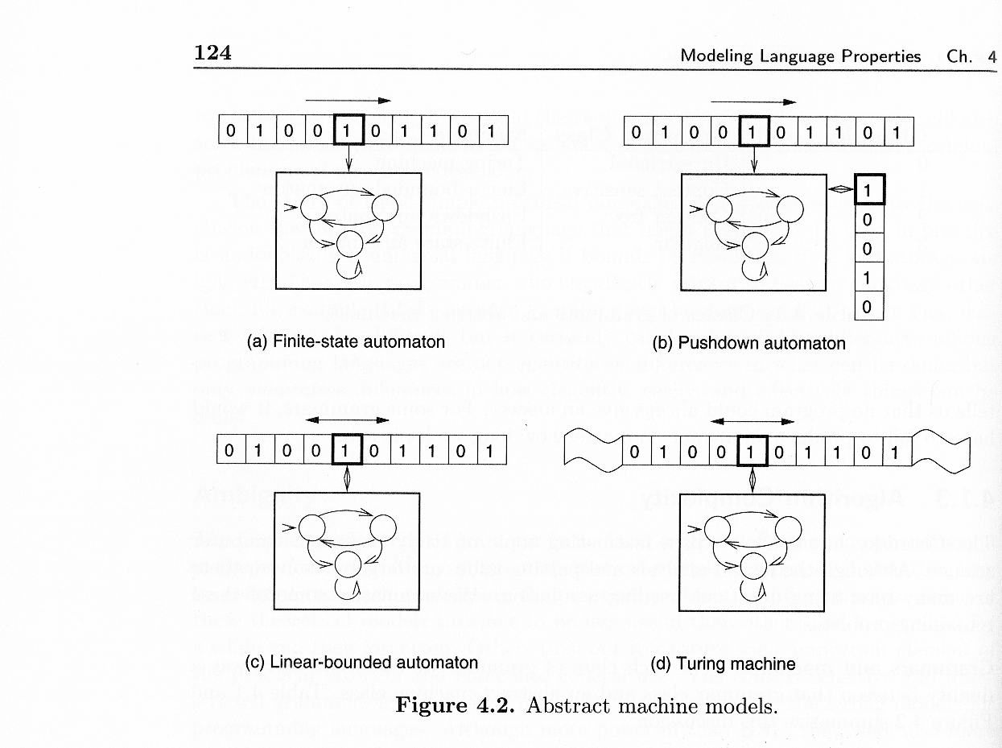

Regular Grammars – Type 3
Languages which have these grammars use regular expressions. A regular expression has rules of the form: <nonterminals> → <terminal> <nonterminal> | <terminal> (Pratt and Zelkowitz, page 99). Notice that a nonterminal does not appear on the RHS without a terminal. These languages have a context. A context, for our purposes, means that past state information is preserved.
This grammar type is represented by a finite state automaton (FSA). As we have already seen, an FSA is a graph which consists of vertices which represent states and edges which represent state transitions. Each edge is given a token which results in that edge being traversed from one state to another. Sometimes the transition is from a state back to the same state when the edge goes from the vertex back to the same vertex. You will notice from the figure [(a)] that it is a digraph.
There are some limitations on what a FSA can do. For example, a string that cannot be recognized is a^{n}b^{n} (string where a is repeated n times followed by b repeated n times). However, this grammar type will recognize if an identifier has been previously declared or not.

Context-Free Grammars – Type 2
These grammars use expressions which differ from regular expressions in that they can have productions of the form: <nonterminals> → <terminal> <nonterminal> | <terminal> | <nonterminal> Notice here that a nonterminal can be one of the choices.
This grammar choice is represented by the push-down automaton (PDA) [(b)]. The PDA uses the Type-2 productions and a stack. The stack can contain symbols or sentential forms. Sentential forms are terms in some production as it evolves from a rule to the final form with all non-terminals. For example, <ident_list> is a sentential form.
The steps for recognition of a string are as follows: (Pratt and Zelkowitz, page 103)
- An input symbol is read and the top symbol on the stack is read.
- Based on both inputs, the machine enters a new state and writes zero or more symbols onto the pushdown stack.
- Acceptance of a string occurs if the stack is ever empty or the final PDA state is reached.
A derivation from a rule to the recognition of a string can also be done:
- If the top of the stack is a terminal symbol, compare it to the next input and pop it off the stack if it is the same. It is an error if the symbols do not match.
- If the top of the stack is a nonterminal, replace it on the stack with something from the RHS of the production rule for the nonterminal.
(We will look at some derivations later.)
These grammars can recognize strings of the form a^{n}b^{n} but cannot recognize if an identifier has been previously declared.

Context-Sensitive Grammars – Type 1
This is a grammar that remembers context by keeping its history in the string. Thus strings in the language are nondecreasing. There are some properties of this grammar that are unknown. This grammar type is little used for programming languages.
The linear-bounded automaton (LBA)[(c)] is a Turing machine (see Type 0 grammars) with a finite length tape. Since the tape is of finite length, the read head pointer cannot move off the end of the tape.

Unrestricted Grammars – Type 0
This is a grammar which can be used to recognize any computable function. Most of its properties are undecidable. That is, it is not possible to decide if a property is true for all Type 0 grammars.
This type of grammar is implemented using a Turing machine [(d)] which was first described by Alan Turing in 1936. Turing was interested in a problem that (more or less) began with Gottfried Leibnitz in the 17th century: Which mathematical problems can be solved? This lead to what is now called the Theory of Computation. In the 19th century this became of great interest to mathematicians. Turing approached the problem by thinking about a machine that could solve problems given no limit on time and the amount of input and memory.
The machine consists of an infinitely long tape where each tape component consists of a single character. There is a read head which reads each tape component. The program driving the machine can take some action depending on the input. The tape can be moved one position to the left or right at any one time. If a shift results in the read head running off the tape, then a new tape with a component is inserted.
One problem that arises with a Turing machine is called the halting problem. The machine halts when the program that the machine is running ends. The problem is will the machine always halt? That is, are all problems able to be computed by the machine? Further it is not always decidable as to which problems will cause the machine to halt and which will not. How long should the machine run before deciding that the problem is not decidable?
This leads into the larger problem. A universal programming language is a language that is general enough to allow any computation to be expressed (Pratt and Zelkowitz, pages 119 – 120). Are standard programming languages universal? Is it possible to build a universal programming language? Is there a machine which can compute all computable problems? Which problems are computable by computers? Church's thesis (Alonzo Church, also 1936) is that any computable function can be computed by a Turing machine (Pratt and Zelkowitz, page 120).
An interesting conclusion is the following (Pratt and Zelkowitz, page 120): It takes almost no machinery to achieve universality, other than some sort of unlimited storage capacity.

BNF
The 1950s were a productive time for programming languages. COBOL, Fortran, and LISP were all developed in that decade. John Backus headed the team at IBM which developed the Fortran language. Backus was also interested in the formal theory of programming languages and started working on this at roughly the same time that Chomsky was working on his classifications. Backus was interested in how to describe the rules of programming languages. To that end he introduced, in 1959, a metalanguage to describe programming language syntax rules. (A metalanguage is a language that describes another language. In Backus' case, it was a language to describe programming languages.) His work was used to describe a research language called ALGOL 58. Peter Naur modified Backus' notation in order to describe ALGOL 60. This result became known as Backus-Naur Form which is usually written as BNF.
BNF is classified as a Chomsky Type 2 or context-free grammar. However, as we have seen above, there are limitations on what such grammars can recognize. We will see later that there have been further modifications to BNF in order to make the notation easier to read and write.

Using BNF
The BNF rules, productions, allow for statements in the language to be recognized as well as generated. These are called derivations. A typical formulation is to start with a set of rules and a statement and see if it is possible to derive the statement from the set of rules. Parsing is a form of syntax analysis which uses the language grammar rules to analyze whether a sentence is a syntactically valid sentence.
As an example, here is a grammar for assignment statements: (from Sebesta, Example 3.3, page 122)
<assign> → <id> = <expr>
<id> → A | B | C
<expr> → <expr> + <expr> | <expr> * <expr> | ( <expr> ) | <id>
We will do a derivation to determine if the sentence
A = B + C * A
is a valid sentence using these productions. What we will do is look at our goal, the sentence under consideration, and determine, using the rules, a way of achieving that goal. Typically there is a production that we start from. This is usually the first production rule stated and is the most general:
<assign> → <id> = <expr>
We can recognize the general form of the expression we want where <id> is the LHS and <expr> is the entire RHS. A direct substitution may be made for <id> as <id> produces only terminals. The lexeme = is a terminal. However for <expr> there are choices to be made so we hold back on any substitutions:
<assign> →A = <expr>
What next? We see that B +C * A fits one of the choices for an <expr> production so we use that one:
<assign> →A = <expr> + <expr>
For the LHS of the + we can: <assign> →A = <id> + <expr> → A = B + <expr>
This leaves us with C * A which fits another of the <expr> choices:
<assign> → A = B + <expr> * <expr>
We can continue this production through substitution:
<assign> → A = B + <id> * <expr> → <assign> → A = B + C * <expr> → A = B + C * <id> →
A = B + C * A
This is the result we were looking for. Notice how at each point we had to make a choice as to how to proceed. The FSAs we have already looked at had definite transitions from one state to another. These transitions from one sentential form to another were less definite. To say this differently, the FSAs we previously used were deterministic. Each edge from a state had a unique transition token which was required in order to traverse that edge. However what we are doing is nondeterministic. This means that an FSA state may have edges where more than one edge requires the same token. Thus a guess has to be made as to which edge to use. This implies that if a guess leads to a dead end, backtracking will be involved.
Notice that in the above derivation we proceeded from left to right. This is called leftmost derivation. However, in a context-free grammar, derivations may also be rightmost (right to left) or neither leftmost nor rightmost. Further, derivations may be, as we saw above, <expr> → <expr> * <expr> or the reverse: <expr> * <expr> →<expr>

Parse Trees
The derivation of a sentence is actually hierarchical. This can be seen through the use of parse trees. Here is the parse tree for the derivation that was just done:
(Sebesta, Figure 3.2, left side, page 123)
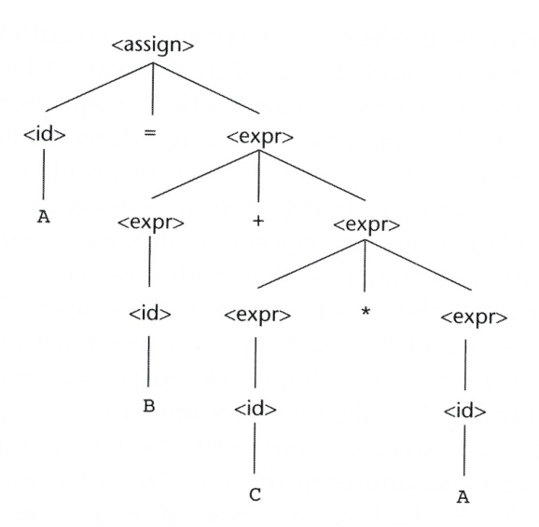
Parse trees are used by compilers when recognizing language elements. One reason for compilers using parse trees is that they are hierarchical which reveals which elements will be performed first. Looking at the parse tree we see that the * operation comes before (lower in the tree than) the + operator. This is the standard operator precedence order. There is a rightmost derivation of the same sentence which will result in a different precedence order as B + C will be the operation performed first:
(Sebesta, Figure 3.2, right side, page 123)
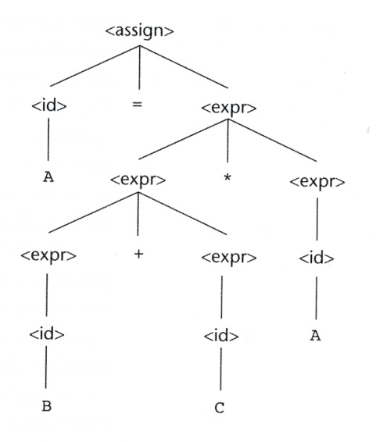
When more than one parse tree can be developed for a sentence the grammar is said to be ambiguous. Compilers have a problem here as the meaning of the sentence cannot be uniquely decided. It is possible for compilers to use ambiguous grammars if there is other meta-information (nongrammatical information) that can be used to determine the correct parse tree.
Is it possible for a grammar to unambiguously provide for operator precedence? Here is one: (from Sebesta, Example 3.4, page 125)
<assign> → <id> = <expr>
<id> → A | B | C
<expr> → <expr> + <term> |<term>
<term> → <term> * <factor> | <factor>
<factor> → ( <expr> ) | <id>
Here is a leftmost derivation for the sentence:
(Sebesta, page 125)
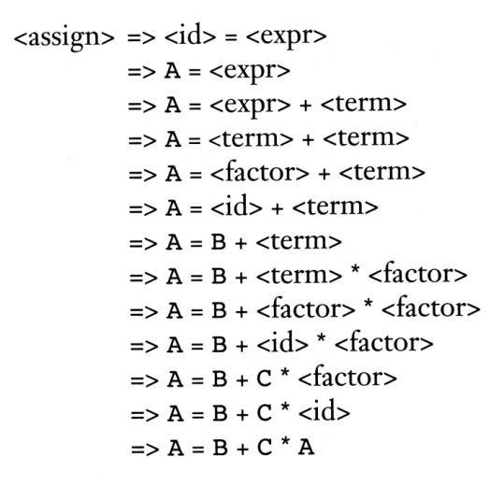
Here is the rightmost derivation:
(Sebesta, page 126)
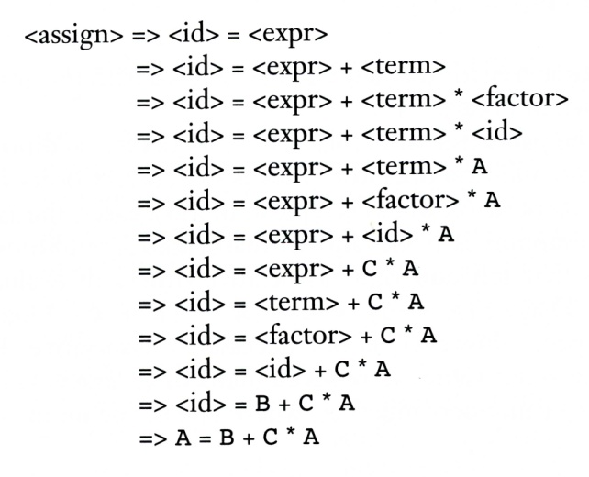
This time they result in the same parse tree:
(Sebesta, Figure 3.3, page 126)
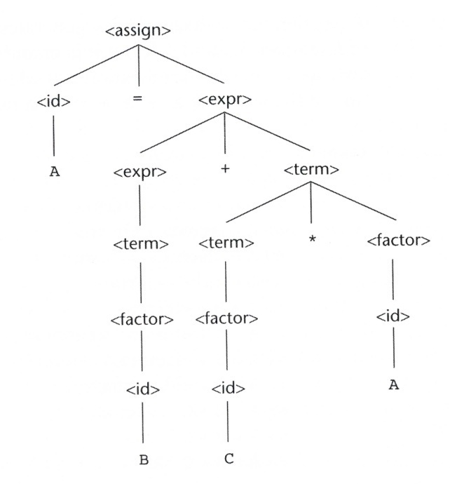

Textbook Derivations
The text's grammar rules use BNF. What the text does is to construct a function to implement the rules rather than go through the more standard derivation. What we will do here is to go through some of the derivations.
On page 161 the syntax diagram shown, which is sometimes referred to as a railroad diagram, is a popular way for textbooks to show the syntax rules of a language. The more formal way, and the way that is amenable to logical analysis, is to use grammars.
The text uses the sentence A2B (page 162) in order to illustrate how its pseudocode function works. This sentence can also be derived through the grammar given on page 161:
< identifier >→< identifier > < letter >
→< identifier > B
→ < identifier > < digit > B
→ < identifier > 2B
→ < letter > 2B
→ A2B
This is a rightmost derivation. We can also start with the sentence:
A2B
< letter >< digit >< letter >
< identifier >< digit >< letter >
< identifier >< letter >
< identifier>
Another grammar that the text shows is one for postfix and prefix expressions. The one for postfix expressions is on page 170. Suppose that we wish to demonstrate that the postfix expression on page 208, abcd*+e/-, is a valid sentence in the language represented by this grammar:
Here is a derivation:
<postfix> → <postfix><postfix><operator>
→ <postfix><postfix> -
→ <postfix><postfix><postfix><operator> - // expanded the last <postfix>
→ <postfix><postfix><postfix> /-
→ <postfix><postfix> e/- // substituted e for the last <postfix>
→ <postfix><postfix><postfix><operator> e/- // expanded the last <postfix>
→ <postfix><postfix><postfix> +e/-
→ <postfix><postfix><postfix><postfix><operator> +e/- // expanded the last <postfix>
→ <postfix><postfix><postfix><postfix> *+e/-
→ <postfix><postfix><postfix> d*+e/-
→ <postfix><postfix> cd*+e/-
→ <postfix> bcd*+e/-
→ abcd*+e/-

Notice that this is a rightmost derivation.
Let us now consider Exercise 6 on page 187. Can we demonstrate that the string in part b) is a part of the language? Looking at the grammar we see that dashes can only be at the beginning of a string while dots can only be at the end. There is no production that will generate the string shown.
What about part c)? To do this, we formulate a string and see if it is in the language. Knowing that dashes must precede dots, we can formulate the following: ----… Here is a derivation:
<word> = <dash><word>
= - <word>
= - <dash><word>
= -- <word>
= -- <dash><word>
= --- <word>
= --- <dash><word>
= ---- <word>
= ---- <word><dot>
= ---- <word> .
= ---- <word><dot> .
= ---- <word> ..
= ---- <dot> ..
= ----…

We now consider Exercise 13 on page 188. What is the grammar for this language? It is apparent that A, B, C, and D are terminals. However, C and D can be followed by a valid string. Thus the following will work: <S> = A | B | C <S> | D <S>
Is CAB part of the language?
<S> = C <S>
At this point we cannot see what to do next. Neither A nor B will lead to a recursive rule. Also notice that this string ends with two terminals which is not part of this language. Thus we must conclude that the CAB is not part of the language.

EBNF
Several enhancements have been added to BNF in order make reading and writing BNF rules less cumbersome. In general this is referred to as Extended BNF (EBNF). While a number of extensions have been used, according to Sebesta (page 132) there are 3 commonly accepted extensions.
One extension is to use square brackets to indicate that something is optional: (Sebesta, page 130)
<if_stmt> → if (<expression >) <statement> [else <statement>]
Here the notation indicates that the else part is optional. Sebesta illustrates what the BNF rule would be: < if_stmt > → if (<expression >) <statement> | if ( <expression >) <statement> else <statement>
Another extension is to use curly braces to indicate that the enclosed part is optional and can be repeated any number of times:
<ident_list> → <identifier> {, <identifier>}
Suppose that the braced part had to be included at least once? A superscript plus sign can be used:
<program> → begin {<stmt>}⁺ end
The third enhancement is to use parentheses to indicate a choice form a list of elements. For example, instead of:
<expr> → <expr> + <expr> | <expr> * <expr> | ( <expr> ) | <id>
We can write:
<expr> → <expr> ( + | * ) <expr> | ( <expr> ) | <id>

Attribute Grammars
It was noted above that context-free grammars cannot specify certain occurrences such as whether or a variable has already been declared. For programming languages this is one of several language syntax issues that cannot be expressed using BNF. Type compatibility rules would also be included here. These problems are in the categories of language rules called the static semantics of a language. While semantics is used here the rules really relate more to syntax. The analysis required to check these specifications is done at compile time. (Sebesta, page 134).
Attribute grammars are used in order to develop the static semantics of a language. Each symbol in the language has a set of attributes associated with it. Attribute computation functions, also called semantic functions, are used to compute the attributes.

Semantics
Semantics, as described above, deals with the meaning of programs. Also as described above, semantics is a much more difficult area to describe. This area is dynamic semantics. Three different methods have been developed to approach programming language semantics.
Operational semantics attempts to describe a program in another language that is more easily understood (Sebesta, page 139). That is, think of, or actually, develop a machine to run the language and see what happens. Pseudocode is often used to describe what some language statement is supposed to do. Tucker and Noonan (Programming Languages: Principles and Paradigms, 2nd Edition, McGraw-Hill, 2007, page 154) state that Fortran was originally described as: "whatever happens when the program is compiled by compiler C and run on machine M."
However, describing the semantics of a language based on a particular machine limits the applicability of the results.
Denotational semantics is described by Sebesta (page 142) as the most rigorous widely used method. The concept here is to use mathematical objects and functions that operate on those objects. The process, as is usual with functions in mathematics, is recursive. It is the most mathematically precise and it is also the most complex. Developing the objects and specifying the functions is challenging.
Axiomatic semantics is the best known as it is used in program proofs. Axioms are logical statements that are assumed to be true (Sebesta, page 148) without proof. An assertion is some expression that is purported to be true about the code that either follows or preceded the assertion. An assertion that precedes code is called a precondition while one that follows code is called a postcondition. An inference rule is a method of inferring the truth of one assertion based on the values of other assertions. Sebesta (page 149)has this example of an inference rule:
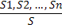
This is defined as: If all the statements in the numerator are true then the truth of S can be inferred.
To put some of this together, let's look at a while loop. The axiomatic description of the while loop is (Sebesta, page 155):
{P} while B do S end {Q}
Where P is the precondition; while and do are keywords; B is the while condition; S are the statements that follow the condition; and Q is the postcondition. For example (Sebesta, page 155, using the C++ operator != instead of the <> operator Sebesta uses):
while y != x do y = y + 1; end {y = x }
Notice that the precondition is missing. We need to determine the precondition. More specifically we need to determine the weakest precondition for this loop. The weakest precondition is the least restrictive precondition that will assure the truth of the postcondition.
One way of determining the weakest precondition is to go through some calculations and determine if a pattern is evident. For zero iterations the precondition would be y =x. For one iteration we can use S, the statement y = y + 1, and the precondition we just developed, y = x. Both express some statement about y so we can use the fact that y is y + 1 in S and substitute this for y in the precondition: y + 1 = x or y = x – 1 This becomes the new precondition for one iteration: {y = x – 1}.
We can now use this precondition to determine the precondition for two iterations: y + 1 = x – 1 or y = x – 2.
Similarly for 3 iterations: y + 1 = x – 2 or y = x – 3.
We can generalize this result to say that for one or more iterations the weakest precondition is y < x. Combining this with the weakest precondition for zero iterations, y = x, we come up with the overall weakest precondition: {y <=x}.
We now look at the loop invariant. A loop invariant is an expression about what must be true before (and after) each repetition of the body of a loop (Tucker and Noonan, page 191). In fact, we can prove if the loop invariant is true or not. Given that the axiomatic description of a while loop is (Sebesta, page 157):
{P} while B do S {Q}
where: P is the precondition, B is the loop condition, S is the loop body, and Q is the postcondition, here is the inference rule for computing the precondition for a while loop :
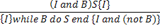

That is: If the invariant and the condition are true and the invariant is inferred by the postcondition, then the invariant is the precondition and the postcondition can be expressed as the invariant and the complement of the condition.
The first thing to notice is that the invariant is used as the precondition. This can be expressed as P →I or that the precondition implies the invariant. Thus to prove that the weakest precondition that was developed is the loop invariant we need to prove:
P → I
{I and B} S {I}
(I and (not B)} → Q
the loop terminates
Since we have made the weakest precondition the invariant, the first requirement has been satisfied.
The second requirement in the example is written as:
{y <= x and y != x} y = y + 1 {y <= x}
y <= x and y != x is true if y < x. Next, doing the substitution as before: y + 1 <= x or y <= x – 1 which also implies {y < x}. Thus this requirement is satisfied.
The third requirement is:
{ (y <= x) and not ( y != x) } → {y = x}
{ (y <= x) and (y = x) } → {y = x}
The first condition is true if y = x thus:
{y = x} → {y = x}
We have already seen that when y = x the loop terminates. Hence it has been proven that {y <= x} is the loop invariant and the weakest precondition.

Sources
Pratt, Terrence and Zelkowitz, Marvin. Programming Languages: Design and Implementation, 4th Edition. Prentice-Hall, 2001.
Sebesta, Robert. Concepts of Programming Languages, 10th Edition. Pearson, 2012.
Tucker, Allen and Noonan, Robert. Programming Languages: Principles and Paradigms, 2nd Edition, McGraw-Hill, 2007.

